 | WINTHROP WEEKLY  NEWS AND ANNOUNCEMENTS FOR THE TOWN OF WINTHROP
 | January 2, 2025
  TOWN OF WINTHROP  PUBLIC CALENDAR  All meetings and agendas are posted up to 48 hours in advance. Click on meeting information below to read posted agendas.  School Committee  January 6, 2025, 6:00 PM  Harvey Hearing Room  More Details  MBHSR Communication Interoperability Subcommittee  January 7, 2025, 10:30 AM - 11:30 AM  More Details  Town Council  January 7, 2025, 7:00 PM  Harvey Hearing Room  More Details  Commission on Disability  January 8, 2025, 6:00 PM  Harvey Hearing Room  More Details  Conservation Commission  January 8, 2025, 7:00 PM  More Details  WHS Site Council  January 9, 2025, 9:00 AM - 10:00 AM  Principal's Office/Conference Room  More Details  Board of License  January 9, 2025, 6:00 PM  Harvey Hearing Room  More Details  Winthrop residents can easily access public meeting schedules and agendas with one click! Simply go to www.winthropma.gov  Reminder:  Trash and Recycling Collection Delay  No collection on Wednesday, January 1st  All trash and recycling collections will be delayed by one day AFTER the 1st for the remainder of the week.      PUBLIC SKATE  Public Skating at the rink begins Sunday October 13th.  Every Sunday 12:40 to 1:50pm for $3.  Stay informed of all town notifications:    Sign up for Code Red & the  Town Manager’s Blog  Town Website  Facebook  Contact the Town Manager’s Office  (617) 846-1705  email: townmanager@winthropma.gov.  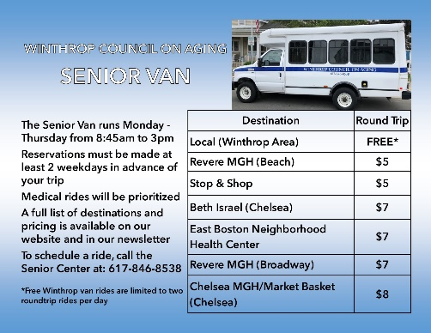  Thrift Shop Dates - 2024  First Church of Winthrop United Methodist  217 Winthrop Street – Back Entrance  Time: 10:00 am – 1:00 PM    2nd and 4th Thursday and Saturday of month  Women’s, Men’s, and Children’s Clothing  APPLY FOR PERMITS ONLINE  The Town of Winthrop has partnered with Open GOV to drive efficiency for staff and improve the quality and convenience of services for community members with technology that automates permitting and licensing approvals processes, allows for online inspections management, and provides a user-friendly online portal for applicants. Residents can now apply for permits, request inspections and access information online from the Building Department and Public Health Departments.  https://winthropma.viewpointcloud.com/  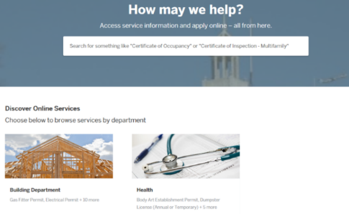 |  | 