Center Business District Revitalization
A Pilot Program to Study the Traffic Flow in and around French Square and Hagman Road

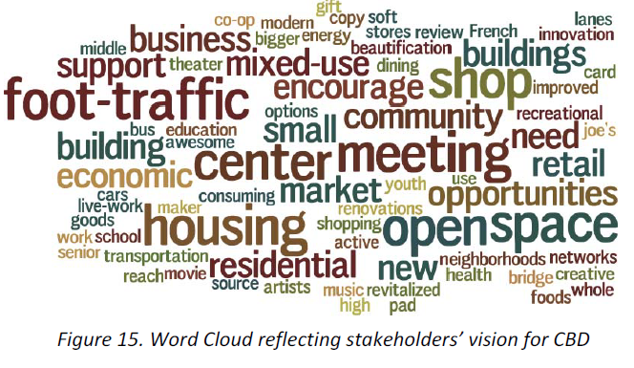

What’s happening in the Center?
What you are seeing and experiencing on the streets in and around French Square is the result of a new traffic study pilot being executed by the Town from August 31 to October 31. As a pilot, these changes are not permanent and are meant to assess the potential for new traffic patterns and access to public spaces to stimulate much needed development and business activity in the Center.

This study features the following changes:
- Closure of Hagman Road to vehicles
- The repurposing of 28 existing parking space on and around Hagman Road
- Reversal of the direction on Adams Street (second half of the study)
- Make Jefferson Street between Putnam and Hagman a one-way outbound
- Allow a left hand turn at the end of Woodside by Cervizzis, allowing vehicles to take a left hand turn to go up Bartlett Road.
Why is this happening in the Center?

This pilot was derived from the recommendations provided by the Centre Business District Master Plan- a comprehensive economic development strategy adopted by the Town Council in April 2017 to strengthen business and commercial activity in Winthrop’s downtown core. The Master Plan established five key goals for the Center, each generated through extensive public input, and focused on creating a vibrant, walkable Center Business District grounded by sustainable local businesses.

Master Plan Goal #1: Enhance the public realm: Revitalize streetscapes and rethink the nature of usable public open space. Redefine gateways to the CBD. Promote the connectivity of Winthrop’s assets. Closing Hagman Road to vehicles and expanding curb and sidewalk space throughout French Square is an attempt to achieve this first goal, while also experimenting with the ways that traffic flows in and out of the Center.
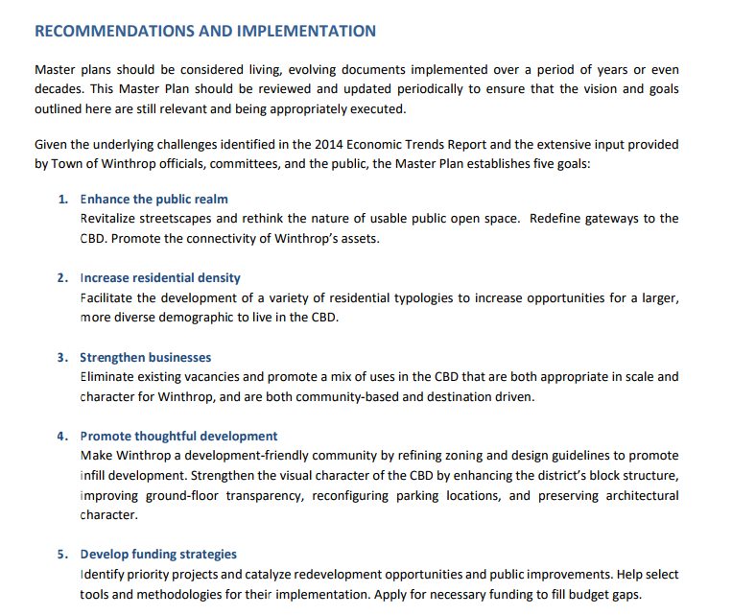
Page 59 and Page 60 of the Master Plan begin to outline the possibility and benefits of turning a portion of Hagman Road into a pedestrian only way. This sentiment is explored throughout the Master Plan and suggests that this project could be Winthrop’s signature feature. There are many more references to this throughout the Plan, and it is absolutely worth the read. The PDF of the Master Plan can be found on the Town of Winthrop’s website.

Will there be enough parking in the Center?
In order to implement the pilot, a total of 28 parking spaces were removed (mainly in the Hagman and Putnam lots). Recent parking studies in the Center have indicated that utilization of on-street and off-street parking is currently at about 48%, leaving ample opportunity to remove spaces and reallocate these spaces for cars to spaces for people (extended curbs, wider sidewalks, walkways etc).
There are several strategies that we can implement now to alleviate any concern that CBD stakeholder may have about parking. One such strategy is to create a CBD Employee Parking Program which would give business owners and employees exclusive use of the Walden Street lot during regular business hours. This lot includes 28 underutilized parking spots at the entrance to the CBD. This way, employees and business owners have a secure place to park, while allowing customers to park as close to the place of business as possible.
What is wrong with French Square the way it is?
The usability of French Square’s quaint park is challenged by its small size and limited accessibility. While the area immediately adjacent to French Square is home to numerous shops and restaurants, they do not take full advantage of the opportunity to engage this key focal point in the Center. There is tremendous potential to transform French Square into a well‐articulated, pedestrian‐friendly environment that accommodates a variety of active and passive recreational uses.
The Center is also characterized by a lack of quality pedestrian streetscapes due, in part, to several underutilized parcels in key locations in the core. This creates discontinuous sidewalks and an inconsistency in architectural detail, transparency and signage in retail storefront design – all essential ingredients for active streetscapes. In addition, there is little usable public open space, which this pilot seeks to resolve.

Why does Winthrop need redevelopment?
The recommendations of the Master Plan address the findings of the UMass Collins Center’s 2014 Economic Trends Report which show Winthrop has experienced decades of population decline and job loss, atypical of similar seaside communities located near a major metropolitan area such as Boston, Salem, and Quincy. The report noted that:
- Winthrop has lost over 1,100 local jobs since 1990 and fewer than 1,800 local jobs remain. The town has only 0.2 jobs per resident in the labor force, which limits the daytime activity necessary to support a diverse commercial base.
- Winthrop is experiencing substantial “retail leakage,” and Winthrop’s residents do approximately 68 percent of their retail spending out of town.
- The town is home to an aging population: during the 50‐year period leading up to 2011, the median age jumped from 33 years old to 43.7 years old.
- It is the only seaside community studied in the report to experience population decline between 1990 and 2010.

Reversing these trends begins by changing our status quo and providing more opportunities for
residential development to drive commercial activity and support sustainable economic growth in the Center.

Recent History of the Project:

2014 and 2015 - the Town of Winthrop undertook an Economic Development Strategic Planning process with the McCormack School at UMass Boston and amended the Centre Business District Zoning with the help of MAPC. The new zoning allowed multi-story, mixed use development by-right across the entire district and included setback, parking, height and use amendments to the old CBD zoning.
Upon adoption of the Economic Development Strategic Plan and new CBD zoning, it was determined that the Centre area utility infrastructure was old and likely incapable of handling the new demands that would be placed on it by redevelopment.
April 2015 – Town Manager hired urban planning and design firm Form + Place to help create a visual rendering of the type of development that is possible under the CBD zoning and begin the discussion about establishing design standards for developers with the Planning Board.
October 2015 – Town applied for and received a $50,000 Urban Agenda grant to begin the process of preparing a plan for the CBD and the old Middle School site. The Metropolitan Area Planning Council (MAPC) pledged another $25,000 in technical planning assistance to assist with the process and Mass Development and HED later pledged additional resources to complete the CBD and Old Middle School Master Plan process and to simultaneously complete the Economic Development Self-Assessment Tool (EDSAT) with Northeastern University.
2016 – CBD Master Plan process was conducted with the assistance of the Council’s Economic Development subcommittee and the Council appointed Economic Development Advisory Committee. During the planning process and the attendant EDSAT process, the age and condition of the CBD utility infrastructure was once again raised as a barrier to redevelopment.
September 2016 – Town applied for MassWorks Infrastructure Program grant in the amount of $2.38 million, as a first step toward addressing the infrastructure needs of the CBD.
April 2017 – Town Council adopted the CBD and Middle School Master Plan
July 2017 – The Executive Office of Housing and Economic Development and Governor Baker announce award of $2.38 million MassWorks grant to support redevelopment of Winthrop Centre.

